Identity in the European Union & Germany by Angelika

Note: Angelica, a Germany girl, instructor of Shandong University, major in translation with economics, has been invited to give a lecture on the making of European identity with the influence of history. She did brilliantly, and both the teachers and the students present were greatly benefited from her presentation, her PPT and her meticulous working style.

The presentation is divided into 3 parts:
Firstly, a short history and overview of the development and the economic as well as political organisation and structure of the European Union.
Secondly, an introduction of cultural diversity and the political steps taken by the EU to unite and protect this diversity with regard to the existence or absence of a European identity. Scepticism towards integration will also be discussed
Finally, I would like to give you a brief introduction of German identity, culture and pride by using the history of its flag as an example.

Outline

1. History of the European Union
1.1. Key dates
1.2. Accession of EU member states
1.3. Fact sheet
1.4. European Union map

2. United in Diversity?
2.1. European identity
2.1.1. National identity - definition
2.1.2. Lingual diversity
2.2. Development towards a united yet diverse identity
2.2.1. Treaties & committees
2.3. Euroscepticism

3. Germany's national identity
3.1. German culture and identity
3.1.1. Stereotype
3.1.2. National pride - patriotism
3.2. The German flag
3.2.1. History
3.2.2. Use
3.2.3. Greece incident

Part I:

- History of the European Union

In order to fully understand the different cultures and identities or cultural identities in Europe, it is crucial to know a little bit about the development of the European Union. This is also necessary to understand the question of whether there is a common European identity or whether it will be possible to create such an identity one day.

In the aftermath of the Second World War, the European Union started off as a purely economic cooperation to better coordinate and organise production. This was at first limited to two core industries: the gaining and processing of coal and steel. It was to be a mere production union.
Soon after the French and the German government had agreed on a mutually beneficial economic cooperation, it also became clear that both sides wanted to open this cooperation and to expand it by inviting other countries to join. The economic predecessor of the EU was born.
As the European Union evolved, it quickly started developing from an economic cooperation into a political association, which then in return also started influencing all areas of life in Europe: from a single market to open borders, from arts to educational systems, from travelling to currency, from housing laws to which ingredients should be in chocolate – there is no single aspect of life nowadays that has been left untouched by the European Union.

1.1. Key dates

1952 ECSC – European Coal and Steel Community
1958 EEC – European Economic Community
1993 EU – European Union

Monetary Union:
1999 Euro – launch
2002 Euro – introduction of banknotes & coins

1.2. Member states of the EU
(year of entry)

6 1952: Belgium, France, Germany, Italy, Luxembourg, Netherlands
+
3 1973: Ireland, United Kingdom, Denmark
+
1 1981: Greece
+
2 1986: Portugal, Spain
+
3 1995: Austria, Finland, Sweden
+
10 2004: Cyprus, Estonia, Hungary, Latvia, Lithuania, Malta, Czech Republic, Poland, Slovakia, Slovenia
+
2 2007: Bulgaria, Romania
+
(1 2013: Croatia)
_____
27 member states of the EU
(28 member states)

Candidate Countries
Iceland, Montenegro, Serbia, The former Yugoslav Republic of Macedonia, Turkey

Potential candidates
Albania, Bosnia and Herzegovina, Kosovo

EU today

The European Union currently consists of 27 member states; in 2013 Croatia will be the next country to join. Iceland, Montenegro, Serbia, The former Yugoslav Republic of Macedonia and Turkey are candidate countries, which could add another 5 countries over the next few years as well as Albania, Bosnia and Herzegovina plus Kosovo are potential candidates. This means that by 2020 or even earlier the EU could include a total of 36 countries in eastern, northern, western, southern and central Europe and with Turkey even be reaching deep into Asia.

The ‘Eastern expansion’ in 2004 not only almost doubled the EU in size; it added a vast new economic, political and cultural dimension. Suddenly the EU was not merely comprised of ‘Western’ European states, but also included most of the east.

The European Union is a hybrid intergovernmental and supranational organization.
The three main decision-making institutions are:

- the European Parliament (EP), which represents the EU’s citizens and is directly elected by them
- the Council of the European Union, which represents the individual member states
- the European Commission, which represents the interests of the Union as a whole

1.3. Fact sheet

Capital: Brussels, Belgium
Note: the Council of the European Union meets in Brussels, the European Parliament meets in Strasbourg, France, and the Court of Justice of the European Communities meets in Luxembourg
(The Hague: International Court of Justice – do not confuse)

Member states: 27
Official languages: 23 (65 regional & minority languages + hundreds of dialects)
Regions: 271

Surface area: ~ 4 million km ²

Population: ~ 495 m inhabitants
Germany: 81.75m
France: 65. 075m
UK: 62. 43m

GDP: GDP total: €12.629 trillion (2011)

Highest GDP: Luxembourg ~ 275%
Lowest GDP: Bulgaria ~ 45%

Region with the highest GDP: Inner London (UK) ~ 330% (UK total 108%)
Region with the lowest GDP: Severozapaden (Bulgaria) ~27%

27 different countries and national cultures plus an infinite number of smaller regional cultures form the European Union.
The diversity can clearly be seen when looking at the number of officially recognised languages. The EU has 23 official and working languages. Certain texts, such as new laws and regulations must be made available in all languages. Most documents, however, are still published in English, although a vast majority of anything published is available in the 3 core languages English, French and German.
Members of the European Parliament have the right to use any of the EU's official and working languages when speaking in parliament.
As a result, the EU employs one of the largest translation forces worldwide with a permanent staff of around 1,750 linguists and 600 support staff. The Commission also has 600 staff interpreters and 250 support staff plus a pool of 3,000 freelance interpreters who are commissioned when needed. (europa.eu)
The questions that arise are “How many languages are too many?” or “Is the EU lost in translation?”

The EU has the third largest population after China and India with around 495m inhabitants. Germany, France and England are the three most populated countries followed by Italy, Spain and Poland.
Germany, for example, is more than twice the size of Shandong, but has almost 20m less inhabitants.
Malta is the smallest member of the EU; it covers 320 km² and has less than 0.5m inhabitants. Given its size, however, this makes Malta the most densely populated European country (global rank 6) at the same time. Jinan, for example, is 25 times bigger than Malta, but has “only” 17 times more people.

Europe in general is quite densely populated; its surface area covers around 4m km², which is less than half the size of the US. The US and China are similar in surface area; China is only marginally larger, the Chinese population on the other hand is 3-4 times the American population. (If Alaska, which is large in size but quite sparsely populated, is disregarded, the United States is more densely populated than it seems at first glance.)

Europe or at least Western Europe is considered to be rich by most of the world. Its GDP seems to be fairly high. Yet - the gap between the richest and poorest regions is vast.
Overall the GDP has soso recovered after the international economic crises and in 2011 as well as 2012 shown modest growth. As we all know, that now with the breakdown of the Greek economy and problems in Spain and Portugal, Europe as a whole still has a long road ahead of it. The path to a full recovery promises to not be an easy one. While, on the one hand, ailing economies have to be stabilised, weak and poor economies, especially in the new (Eastern European) regions, on the other hand, need to be boosted to catch up with the rest of Europe.
In general there are two main divides in the EU: the northern&central/southern divide and the east/west divide since 2004 (this divide is not only an economic, but also a historical, political, social and cultural divide).

1.4. Europe Map

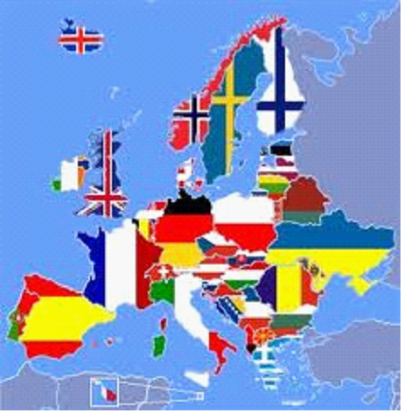

By dividing Europe into regions, the European Union has created a tool that allows it to address individual areas as well as the identification of issues is facilitated. Local and regional factors such as key industries, demographics, geography, education and culture can be taken into account rather than just pushing a country by country or a single European solution (centralisation). The European Union actively does not pursue a “one size fits all” policy, which is, however, still not the way it is perceived by the public despite all efforts towards a federalisation.

Part II

2. European Identity

2.1. “United in Diversity”? …

… is the motto of the European Union.

”The motto means that, via the EU, Europeans are united in working together
for peace and prosperity,
and that the many different cultures, traditions and languages in Europe
are a positive asset for the continent.”
(europa.eu)
Is it possible to unite such a large number of countries and regions politically, financially, socially and of course culturally to form something that resembles a common European identity?

And what does the word identity actually mean?
In order to understand the tremendous task at hand I would like us to have a closer look at the definition of ‘national identity’.

2.1.1. National Identity
The depiction of a country as a whole, encompassing its culture, traditions, language, and politics.
(Source: Dictionary.com's 21st Century Lexicon; © 2003-2012 Dictionary.com)

→ a common identity creates a political community
→ a common identity creates a psychological bond
→ common elements: national symbols, language, national colours, the nation's history, national
consciousness, blood ties, culture, music, cuisine, radio, television

Does the lingual diversity in Europe support or hinder paving the road towards a common identity?

2.1.2. Lingual Diversity

Language is regarded as one of the key elements that unify a people (see definition of ‘national identity’). Communication is perceived as an utmost priority to create a unity that is based on understanding and not on pressure or force.
(When going back in time to the Emperor of Qin, one of the first steps he took was to introduce standardized Chinese writing to create a political and economic foundation on which the newly formed China could grow. This was met by a lot of rebellion by the civilian and academic population. In order to solve the problem at hand, most scholars were executed. “Peace” and communication suddenly seemed feasible, but as unity was introduced by force, it was short-lived. Shortly after his death, his tomb was destroyed in an act of revenge by the people who had felt oppressed rather than included. The road to a united China was (and still sometimes is) a stony one and it has been 2200 years.)
Real integration and thus unity needs to be based on communication. Communicating sounds easy, but is not:

23 official and working languages:
Bulgarian, Czech, Danish, Dutch, English, Estonian, Finnish, French, German, Greek, Hungarian, Irish, Italian, Latvian, Lithuanian, Maltese, Polish, Portuguese, Romanian, Slovak, Slovene, Spanish and Swedish

Exception and changes:
Austria: German
Belgium: Dutch, French and German
Cyprus: Greek
Luxembourg: German, French – Luxembourgish is not an official EU language

2007: Gaelic was recognized as Ireland’s official language

Clearly, just the mere number of official and working languages shows that lingual diversity is wanted and should be part of a European identity; the European Union may even function as a motor that empowers countries to emancipate themselves and to even revive seemingly “lost” languages (e.g. Ireland) and therefore creates even more cultural diversity.
Does this lead to confusion or to the development of a diverse yet common identity that is as unique in its makeup as the EU itself?
And how do people communicate? Economic growth and political stability need a communication platform to prosper.

Language is the reflection and manifestation of history and culture. It is an integral part of a person’s identity and heritage. Language is also key to a thriving economic platform, employability and mobility.
Overall, Europe is doing a very good job at educating their young on how to fit into a globalised world and also a united Europe.

Language acquisition in the EU:

Germany
EN | 94.3
FR | 28.7
DE | — | United Kingdom |  | France
Netherlands |  | EN | — | EN | 99.4 (*)
EN | 100 | FR | 6.0 | FR | —
FR | 70.1 | DE | 2.6 | DE | 22.8
DE | 86.2 | Ireland |  | Greece
Poland |  | EN | — | EN | 94
EN | 90 | FR | 60.5 | FR | 8.6
FR | 10 | DE | 18.2 | DE | 2.9
DE | 64

What is very obvious is the low number of British pupils learning a foreign language. Yes, English is the global language, but apart from Wales where students have to also learn Welsh, the educational system and the British society do even worse than the US. The US is quite famous in Europe for their limited cultural education. The UK does not have that reputation of cultural narrow-mindedness, but those figures tell a different story. At least in the US a huge proportion of people speaks Spanish as a first or second language as well as Italian, Greek, Chinese and other minority languages are spoken, though not extensively taught.
I cannot go into the details of the UK’s history and (lack of) integration into Europe, but its island status does factor in.
Yet, it is not an excuse: Ireland’s approach seems to be one of integration through emancipation. The Republic of Ireland, also an island, which often was considered to be just an extension of England seems to have used the EU to emancipate itself from England, not only economically and financially (Euro), but also linguistically. In Ireland (first language is still English), additionally to learning either French or German, all children that grow up in or move to Ireland before the age of 10 must learn Gaelic as well.
(According to a survey from 2011, Ireland is one of the three happiest member states (> 80% support membership), while the UK is the unhappiest with its membership with only 28% of all citizens favouring membership.)

Looking at the number of children and teenagers that learn another European language is generally quite a good indicator as to how open the respective country is towards a united Europe. Not teaching the next generation another language (or two) means you are distancing, perhaps even isolating yourself from your neighbours. You are not making the effort to understand them – literally understand them – to get to know their culture and who they are. Who we are as Europeans.
The relatively low numbers of Polish and German students learning French as a second or third language is due to the fact that students also can choose Latin as well as that Russian is a common choice in Poland and Spanish (or Italian) one in Germany. The same applies to French students who can also choose, for example, Latin or Spanish instead of German – depending on the school.
Many students outside the UK need to learn 4 languages in total: their native language, English, Latin or German, French or Spanish, some also learn Italian or even Chinese.

2.2. Development towards a united yet diverse identity

2.2.1. Committees and treaties

Already in 1973, when the EU was still a mere economic bloc, the necessity of a political and cultural identity to bind together its members had become abundantly clear:

1973 The Declaration on European Identity of 1973 – political identity (Western values)

“The Nine member countries … have decided that the time has come to draw up a document on the European Identity. This will enable them to achieve a better definition of their relations with other countries and of their responsibilities and the place which they occupy in world affairs.”

- a “common European civilisation”,
- a “common heritage”
- “converging” attitudes and ways of life

…followed by

1974 Resolution on cultural heritage (European Parliament)

1989 – 1991 Collapse of Communism in Eastern Europe

Historically (the development during the aftermath of WWII especially with the isolation of Russia, the “red scare” and the beginning of the “Cold War”), when saying Europe, Western Europeans always only referred to Western Europe. Eastern Europe was so near and yet so far, cut off by that impenetrable, invisible “iron curtain”.
With the collapse of communism and after the initial euphoria about an open Europe had worn off, the arrival back in reality proved to be a rough awakening. The economic gap, the political turmoil, which in former Yugoslavia resulted in the Balkan war, the language barrier (Western Europe had to learn English, Eastern Europe Russian) made seem our neighbours like strangers that had nothing in common with us – there was barely any common ground to be found. Suddenly Europe had two societies: one based on Western values and culture and one based on Eastern culture with the absence of any apparent, tangible Eastern values as the era of communism was over and all there seemed to be was a big philosophical black hole.

During these times, the “Western” European Union nevertheless moved forward:

1993 Treaty on European Union (Maastricht Treaty)

Article 167 (ex-Article 151 TEC): “… the Community must support and supplement action by the Member States in order to conserve and safeguard cultural heritage of European significance. “

→ first: built-heritage
→ later: movable and immovable heritage (museums, collections, libraries and archives);
archaeological and architectural heritage; natural heritage (landscapes and sites of natural
interest); linguistic and gastronomic heritage, and traditional occupations.
→ cultural & economic aspects are covered
→ EU should be "encouraging cooperation between Member States and, if necessary, supporting
and supplementing their action" in the field of culture
→ EU does not have decision-making power in the cultural heritage policy (europa.eu)

In an effort to decentralise (to federalise) the EU, to become more tangible for the average citizen and to distribute its power back to the regions, the small, until then not represented communities, that, however, are the birthplaces of Europe’s diversity, were given a voice:

2002 Committee of the Regions – influence on policy-making directly from the regions

→ complaint: EU is too centralised; disconnect with the regions
→ 2002: formation of the Committee of the Regions
by now: 344 members appointed by the respective member states for 5 years

Influence on policy making in the following areas:
    - territorial cohesion
    - economic and social policy
    - education, youth and research
    - environment, climate change and energy
    - citizenship, governance, institutional and external affairs
    - natural resources

2004 EU – Eastern expansion

After a period of more than 10 years of an open yet not completely peaceful Europe, a “Western” European Union turned itself into a true European Union. This by any means does not embody a transformation into to a less fragmented Europe, the disjoint inside Europe and personal animosities often based on economic worries and the fear of loss of individual identity was actually exacerbated by the geographical union of east and west. It seemed that the greatest challenge the EU ever had to face lay ahead, until ironically some old and established members experienced great economic turmoil. Currently, not so much the east/west but the good old north/south divide is of much greater concern: the EU’s ailing southern European economies.

Still, this expansion required a revision of the EU’s approach to its members to provide its citizens with trust and faith that integration is beneficial and does not lead to the loss of culture and identity, but may even open new doors towards promoting a region’s individuality:

2007 European Commission: European Agenda on Culture

→ the national authorities, the cultural sector and EU institutions should promote:

- cultural diversity and dialogue (intercultural dialogue, skills and mobility)
- culture as a catalyst for creativity and innovation – (cultural and creative industries, culture and regional development and cultural heritage)
- culture as part of the EU's international relations (culture and external relations)
(ec.europa.eu)
The biggest milestone towards the perpetuation and inclusion without dissolution of diverse cultures and identities was probably the Treaty of Lisbon:

2009 Treaty of Lisbon
- Cultural Heritage:
Article 3.3. (TEU): “(…) The Union shall respect its rich cultural and linguistic diversity, and shall ensure that Europe’s cultural heritage is safeguarded and enhanced.”

- European Commission has to consult with local and regional authorities
- European Commission has to consult the Committee of the Regions as to whether a proposal concerns or affects local or regional authorities

[Further reading
European identity
“Can a Common European identity become a reality?
The point of departure of most discussions on European identity is the idea that a political community needs a common set of values and references to ensure its coherence, to guide its actions and to endow these with legitimacy and meaning.
With the fall of Communism in Eastern Europe in 1989, and the founding of the 'European Union' with 1992's Maastricht Treaty - which gave the European Communities new and stronger competences in a wide range of areas (such as foreign affairs, security and defence), two issues gained renewed urgency: defining the EU's borders and boosting the political legitimacy of the Union in the eyes of its citizens: the 'glue' that unites all Europeans and keeps the bloc together.
“What is distinctive about Europe as opposed to Asia or America or other global identities?”
Following the collapse of communism, the unification of Germany, the growing significance of the European Union, the declining significance of the Second World War for contemporary political culture, and the emergence of a European public sphere, a European identity has emerged.”
(Gerard Delanty/University of Liverpool).]

2.3. Euroscepticism

Definition:

- soft euroscepticism: the contingent or qualified opposition
- hard euroscepticism: the outright rejection of the process of European integration
(definition by Aleks Szczerbiak and Paul Taggart in 2001)

Soft euroscepticism:
- opposing closer links with the European Union
- opposing to give further power to the EU
- opposing a deeper integration of the individual countries

Reasons:
- fear of loss of independency, power, control, national identity

Creating a legal basis by passing laws, by publishing agendas, by establishing committees and projects and by decentralising the structure to actively integrate the regions into the decision-making process does not automatically disperse fears. The individual needs to believe in and want to build the foundation of a ‘common ground’ (physically and philosophically) on which a joint identity can be developed.
The question is not only whether a European identity can become a reality, but also whether a European identity is wanted in the first place. As long as the question of integration of any kind is an issue for a majority and not a small minority, no basis, no foundation for any common identity is provided.
The economic crisis took the identity issue to a new high (or low). With the economic crisis, the origins of the EU are being suspiciously examined (which were purely economic ones) and even possible dissolution of economic ties is voiced. This would be like pulling the rug from under the EU’s feet.

Part III

3. Germany’s national identity
Germany is
„Das Land der Dichter und Denker“
(the country of poets and thinkers)

3.1. German culture and identity
Germany is famous for its
→ literature and philosophy
→ classical music
→ architecture
→ scientific and technological discoveries & inventions
→ bread and beer,
but what does being German mean?

The deepest cut in German history was undoubtedly WWII; the Third Reich and the holocaust.
German national identity did not only come to a halt, it simply ceased to exist. German identity certainly needed to be transformed, but instead it was obliterated. A big factor was the ‘collective guilt’ of the German people for their role in the Third Reich. This prevented German families not only from openly grieving for lost family members (1 out 11 Germans had died as a result of the war, bombings or persecution), this paralysis of emotions almost led to a standstill of cultural development until the 1960s.
German development had more or less been solely restricted to economic development. Despite an active and open political movement straight after the war, with the division of Germany into two politically independent countries, it took until the 1990s for a chance to eventually maybe re-establish a unified German national identity.

Before we examine the self-perception and self-image of a modern German, I would like to have a look at the outside view first: the stereotype. Sometimes funny, sometimes hurtful. Sometimes peculiar, sometimes cute. Sometimes appreciative, sometimes offensive and derogatory.

3.1.1. Stereotype
I randomly picked the first 3 stereotypes I found online that apparently describe typical German traits. And this is what they say.

So what is the image and reputation of a German in the world?

→ beer-drinking, blond hair, lederhosen, sauerkraut,
megalomania, efficiency
→ blonde, blue-eyed pale Aryan (just look at me)
no humour, diligent, steal the sun loungers
→ reliable, hard-working, no sense of humour

Stereotypes can be true, but very often are based on unqualified perception and lack any backing by hard data or facts. In the case of Germany, stereotypical clothing, food and drink only refer to (a part of) Bavaria. Historical stereotypes that depict a German as a racist or “Nazi” (mentioning the term “Aryan” is enough) are also common, but usually reserved for times during which political or economic friction between another European country and Germany occur.

Facts

→ beer: highest per capita consumption of beer
Yes, Germany (especially in Bavaria and Franconia - where I am from) has the highest density of breweries and yes, the average annual per capita consumption of beer exceeds that of the rest of the world. (Personally I do prefer dry, red wine.)

→ looks: majority of all Germans have brown hair or/and brown eyes
No, most of us are not blond or/and blue-eyed. Never were and never will be.

→ humour: German cabaret (1901) is older than British cabaret (1912)
Humour and satire as an officially recognised and marketed art form has a longer history in Germany than in England despite the fact that British dry and black humour is world famous, while Germans apparently have no sense of humour. Due to the absence of censorship during the Weimar Republic (between the two world wars) the business of humour greatly flourished in Germany above all other countries. The origins of cabaret lie in neither country; cabaret is a French invention.

→ punctuality: 20% of all long-distance trains are late 90 – 95% of all trains are punctual (punctual = <6 min late)
“Sorry, I'll be late, I'm going by rail. “

One of the most impressive experiences of life in China is the punctuality of the rail. Most Germans might be on time; an institution as traditional and typical for Germany as the German rail (trains were invented in Germany, in my area – Nuremberg and Fürth – Middle Franconia), however, is frequently late. In order to appear more punctual, the German rail even changed the definition of “punctual”: punctual does not mean on time anymore, but less than 6 min. late.

(Several years as a pupil and later as a student I was late in the mornings. Late precisely by 7 min. every morning as the only connecting train I could take to town was precisely 7 min. late every morning over a period of more than 8 years until the problem could be solved. Soso solved. Now the delay times vary.)

3.1.2. National pride – patriotism

Germany does until today not have an overwhelming sense of pride and patriotism.

According to recent surveys, more than 60% of all Germans seem to be proud of being German. The young generation especially seems to have developed and re-ignited a sense of patriotism.

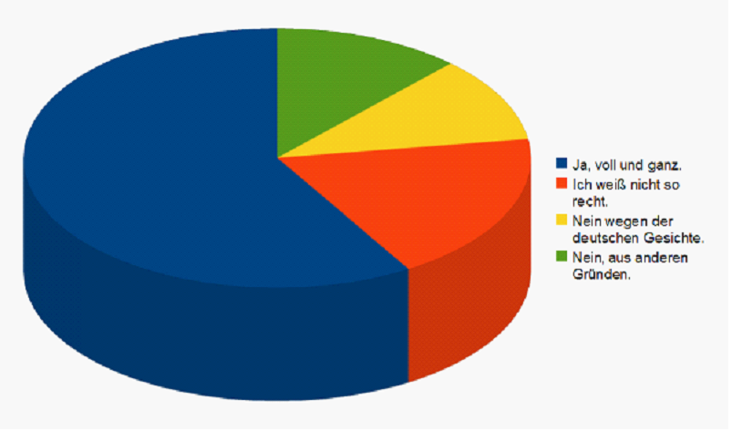

(argentinien-austausch.de)

I am not familiar with the exact questions that were asked in those surveys. To me personally, the question of “Do Germans have national pride?” needs to be divided into three parts as pride does not equal pride. There are different types and shades. ‘Pride’ is not a straightforward term in Germany, it contains many facets:
→ proud to be German?
→ proud of Germany?
→ happy to be born & raised in Germany?

Proud to be German?
No. I didn’t choose. Nobody chooses where they are from.

Proud of Germany?
I believe that achievements such as our social security system as well as our education system are exemplary.

Happy to be born & raised in Germany?
Of course. Everybody has great access to great medical care and great education everywhere regardless of someone’s family background.
You can drink the tap water, there is hot water coming from almost every tap and there is bread, a lot of good bread, and Aldi’s.
Also, especially in the countryside and in small towns, life is free, safe, peaceful, green and clean.

Not having the type of “national pride” that seems all too natural to French, Chinese or American people (to just name a few very patriotic countries) does not mean that there is no pride or ignorance towards one’s achievements.

→ regional rather than national pride
→ pride in the social security system
There is plenty of regional pride, which also is not uncommon for any other European, your area is and always will be the best and very close to you. Of course you may criticize what goes awry in your region, but an outsider better had not. The same rule applies to criticism directed at the local football team.

There is one point, however, where all Germans are proud. This is the social security system. Flawed and expensive as it may be, it does separate us from the rest of the world and makes us a better country. Recent changes to cut costs, necessary as they might have been, are greeted with suspicion and open disagreement because we pride ourselves in providing the world’s best social environment regardless of your age, gender, status or financial and educational background.
If you are in need, your country will take care of you.

The reasons for a continuously low level of patriotism are still founded in the…

… difficult historical self-image
→ national guilt: WWII; holocaust
→ fear of being considered a “Nazi“

People do not necessarily feel ashamed anymore, but nobody wants to be called or even thought of as a Nazi. Any display of too much German just does not feel right.
I would like to illustrate this by means of the German flag, its history and use.

3.2. The German flag
Ironically, the German flag never symbolised anything that was even remotely national-socialist. Yet, a display of German colours outside the context of international football tournaments is the fastest way to be perceived “Nazi.”

3.2.1. History
The German flag and its colours always have represented voluntary unity, freedom, equality and peace. It was born in a movement against oppression and pro-democracy, which is why it was adopted as the national flag in 1848/49 as a representation of the people and discarded after the German War during which the Prussian empire took over the reins. It was adopted as national flag again in 1919 after WWI and then after WWII in 1949, both times still representing the old core values of unity, freedom and equality.

1813 Lützow Free Corps – voluntary (student) force during the Napoleonic Wars – the colours black, red & gold
1848/49 Revolution – anti-monarchy movement
1848 – 1866 “Paulskirchenregierung“
1866 German War or 'Unification War'
→ Prussian dominance over German states (Prussian flag)
1919 – 1933 Weimar Republic → symbol of unity and freedom
1935 officially banned (“Reichsflaggengesetz”)
since 1949 Federal German Republic
3.2.2. Use
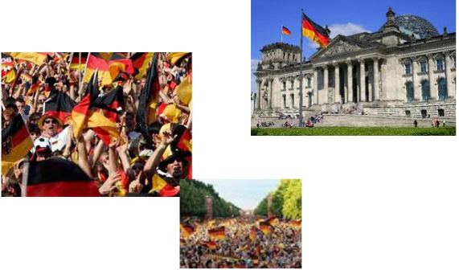
→ at government buildings
→ during international football matches

Of course the national flag has been displayed outside governmental institutions. Until 2002, when Germany lost in the final of the football world cup, but greeted its national team like heroes, there had never been so many German flags on the streets.
This phenomenon also needs to be contributed to the large Turkish German community that has no problems whatsoever to display and to celebrate its national colours with pride.

Since, an ocean of flags can be seen during the world cups. Public viewings of international football matches and parades after a win have brought the flag back. Private use of the flag is pretty much exclusively limited to such events. Such displays of patriotism are not popular with all people. Especially leftist political groups eye such behaviour with suspicion and sometimes even spite.

3.2.3. The Greece incident

Anti-austerity demonstrations (reaction to a speech by A. Merkel)
Oct 2011 A street poster in Greece has depicted Angela Merkel in a Nazi uniform
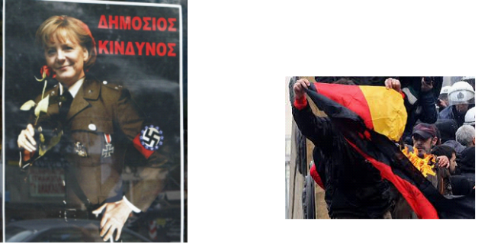
with a swastika surrounded by the EU stars. The accompanying words describe her as a 'public nuisance'.

Feb 2012 Greeks burn German flag in Athens

23 official languages:

